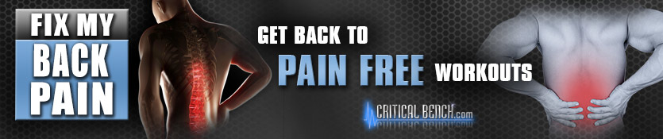
Prelaunch Swipe eMails
Contest Runs Monday Oct 7th – Wednesday the 9th

Your Prelaunch Affiliate Link:
http://xx.criticalb.hop.clickbank.net?w=112
NOTE: Replace "xx" with your clickbank nickname. The affiliate link above is the same link that will be pointing to the sales page when Fix My Back Pain goes live on Tues. Oct 18th.

Fix My Back Pain Affiliate Tools & Prelaunch Banner Options:
http://www.criticalbench.com/gains/fmbp-jv

Schedule:

Monday the 9th: email to Free Health Alert & Comic Strip Optin.
Tuesday the 10th: Use social media banners.
Wednesday the 11th: Last chance to claim your free report.



Email to Send Monday October 7th:

Subject: #1 Worst Exercise (Never Do This!)
Subject: HEALTH ALERT: 5 Pitfalls at the Gym Leading to Back Pain
Subject: 5 of the Worst Things to do at the Gym…
Subject: Download this crucial Health Alert - FREE
Banner image 1: http://www.criticalbench.com/gains/wp-content/uploads/2013/10/mad-mitch-300x250-5.jpg
Banner image 2: http://www.criticalbench.com/gains/wp-content/uploads/2013/10/mad-mitch-300x250-4.jpg
Banner image 3: http://www.criticalbench.com/gains/wp-content/uploads/2013/10/mad-mitch-300x250-3.jpg
Banner image 4: http://www.criticalbench.com/gains/wp-content/uploads/2013/10/mad-mitch-300x250-2.jpg
Banner image 5: http://www.criticalbench.com/gains/wp-content/uploads/2013/10/mad-mitch-300x250-1.jpg

I hope you had a great weekend.
Check out this comic strip with Mad Mitch, it's pretty
entertaining and you'll probably recognize some faces.
They call him the angriest trainer in the world because
he can't stand it when people do dumb stuff at the gym
including dangerous exercises and horrible stretches.

Mad Mitch Shares #1 Worst Exercise & Stretch < ---- Free Comic Strip
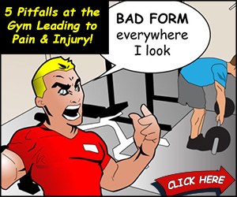

Click Here To See the Full Comic Strip

By the way, the third movement is the one that almost
everyone screws up.
Sign Off

P.S. You'll also get a complimentary Health Alert pdf
called, 5 Pitfalls in the Gym Leading to Pain which
explains why Mitch is so mad and shows you how
to correct potentially dangerous mistakes in just minutes.

Download your FREE Health Alert here.

Tuesday October 8th:

Resend the email above with FW: at the beginning of the subject line and just add a line of red text to the top of the email body that says:
I just wanted to make sure you saw this yesterday. People are getting a real kick out of it and I thought you would too….

Post any of the following on your Facebook fan page with a headline and your affiliate link:
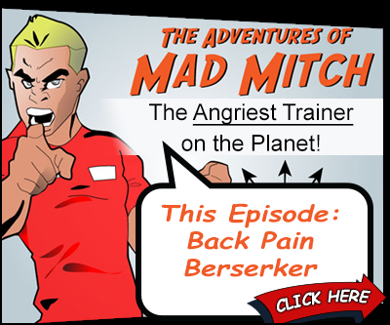

Image url: http://www.criticalbench.com/gains/wp-content/uploads/2013/10/mad-mitch-400-1facebook.jpg
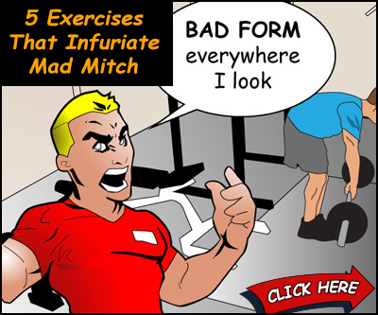

Image url: http://www.criticalbench.com/gains/wp-content/uploads/2013/10/mad-mitch-400-2facebook.jpg

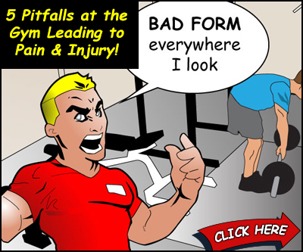

Image url: http://www.criticalbench.com/gains/wp-content/uploads/2013/10/mad-mitch-400-3facebook.jpg
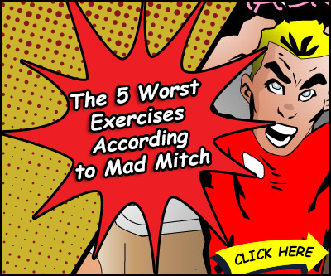

Image url: http://www.criticalbench.com/gains/wp-content/uploads/2013/10/mad-mitch-400-4facebook.jpg

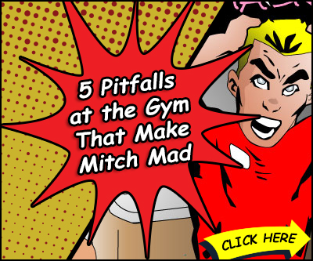

Image url: http://www.criticalbench.com/gains/wp-content/uploads/2013/10/mad-mitch-400-5facebook.jpg

Email to Send Wednesday October 9th:

Subject: This Stretch is Horrible for You…
Subject: HEALTH ALERT: Top Ways to Get Hurt at the Gym
Subject: (Last Call) 5 of the Worst Things to do at the Gym…
Subject: (Last Call) Download this Crucial Health Alert - FREE
Image url: http://www.criticalbench.com/gains/wp-content/uploads/2013/10/HealthAlert1Worst425.gif

Did you download your free Health Alert report yet?

Almost everyone suffers from back pain at some point in their life
that stops them from working out. This free pdf outlines the top
things in the gym you need to avoid doing and what you should
do instead.

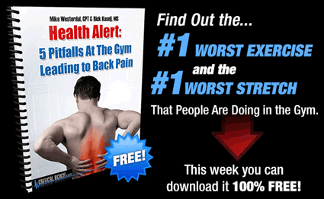

5 Pitfalls at the Gym Leading to Pain & Injury <<< Free Today

Even if you're not having pain right now I still recommend you
download this while it's free so that you don't wind up doing
something that aggravates a lesser issue into something more
serious.

Sign Off

P.S. Today is the last day I'm going to remind you about the Health Alert.

Click Here for the #1 Worst Stretch You Shouldn't Be Doing…

Prelaunch Prizes!
(Requires Sending Minimum of 2 eMails)
1st place most hops: iPad 2


*BONUS CASH*
Reach 10K hops= $500

Reach 5K hops= $250 VISA Gift Card

Reach 2500 hops: $100 Airline Gift Card

